

**SYNC+3.0 Carrier Subscription**

**Feature Document (FD)**

***V1.0***

**Document Status:** Initial Release

**Document Type:** Feature Document (FD)

**Classification:** Confidential

**Department:** Enterprise Connectivity & Digital Experience

**Author:** Shawn Lin, Lu Chao

|  |  |
| --- | --- |
| Reviewing Manager: |  |
| Document Location: |  |
| Date Released: | <Date the reviewing manager approved this document MM/DD> |

**Feature:** SYNC+3.0 Carrier Subscription

Contents

1 Introduction 3

1.1 Validity 3

1.2 Abbreviation 3

2 Process 5

2.1 Document Flow 5

2.2 Feature Proof 5

3 Use Case 6

3.1 Use Case 6

3.2 Sequence Diagram 9

4 Feature Requirements 12

4.1 SYNC+ Requirements 12

4.2 Cloud Requirements 17

4.3 Mobile App Requirements 21

5 Non-Functional Requirements 22

5.1 Data Usage and Collection 22

5.2 Cyber Security and Privacy Control 22

6 Feature Architecture 23

6.1 Boundary Diagram 23

6.2 Boundary Description 24

7 Appendix A: History 25

# Introduction

Nowadays Ford offers 1.2GB free data every month for customers to enjoy entertainment applications (Suixinting & iQiyi). When these free data are depleted, customers need to purchase additional data from carrier. To appeal to the growing customer data consumption and explore the corporate monetization opportunity, carrier subscription feature is rolled out to SYNC+ 3.0 programs.

The key concept is to transition the dimension of subscription package from amount (GB) to service period (year or month). During this service period, the data usage is unlimited.

The service period and the content (i.e. list of the applications) of the subscription package are configurable in cloud backend. At present the planned applications consist of:

* Sui Xin Ting
* iQIYI
* DLNA
* Muse
* Cabin On-Live

While customers are offered a subscription package with competitive price and better experience, Ford can also generate revenue since the wholesale mode is profitable over the data unit cost for OEM.

## Validity

This document is defined for all Ford & Lincoln branded SYNC+ 3.0 vehicles. Vehicle connectivity is essential to carrier subscription feature, which is achieved via the TCU/ECG with an activated SIM card. The user shall register an eligible vehicle VIN (defined as a VIN which is known to have a TCU/ECG installed and has sent a provisioning message to the VSDN / TMC) and complete the authorization process for the eligible vehicle VIN.

## Abbreviation

|  |  |
| --- | --- |
| **Acronym** | **Description** |
| API | Application Programming Interface |
| APN | Access Point Name |
| CDSID | Corporate Directory System IDentification |
| DLNA | Digital Living Network Alliance |
| FM | Frequency Modulation |
| FNV | Full Networked Vehicle |
| HMI | Human Machine Interface |
| IVI | In Vehicle Infotainment |
| KPI | Key Performance Indicators |
| PII | Personally Identifiable Information |
| QR | Quick Response (Code) |
| RNR | Real Name Registration |
| SKU | Stock Keeping Unit |
| SPII | Sensitive Personally Identifiable Information |
| URL | Uniform Resource Locator |
| VIN | Vehicle Identification Number |
| WIR | Wireless Interface Router |

# Process

## Document Flow

All new Ford & Lincoln programs equipped with SYNC+ 3.0 are entitled of carrier subscription feature. This document provides the use case, sequence diagram, feature requirement, non-functional requirement and architecture etc.

This document is the basis for function requirement specification and test methods specification. All the defined features should be tested.

This documents will be reviewed and revised irregularly to provide better customer experience.

## Feature Proof

All features should be tested. And every feature should have one or more test cases in order to cover the corner cases.

Every cases are verified on both test bench and real vehicle as much as possible. For the test cases that are difficult to reproduce on real vehicles or test bench, this info should be defined in test methods specification.

For feature proof, three roles are defined:

1. Test leader: build test bench(hardware/software), make test plan, review test result, release test report, errors tracking and test report summary.

2. Tester: maintain test bench, prepare vehicles, operate test cases, edit draft test report and log/results upload.

3. Tech Lead: clarify feature definition, review test case, support test defect fix and final signoff.

# Use Case

## Use Case

|  |  |
| --- | --- |
| Use Case ID |  |
| Use Case | IVI performs data usage statistics |
| Pre-Conditions | Vehicle is connected to the Internet. |
| Trigger | Vehicle ACC ON |
| Expected Behavior | IVI starts data usage statistics for all features until ACC OFF. |
| Post Conditions | Based on data usage statistics, the left data quota is calculated. |
| Exceptions | IVI service / application crash |

|  |  |
| --- | --- |
| Use Case ID |  |
| Use Case | IVI uploads data usage statistics to Ford IVI service layer cloud after ACC OFF |
| Pre-Conditions | Vehicle is connected to the Internet. |
| Trigger | Vehicle ACC OFF |
| Expected Behavior | IVI ends data usage statistics and uploads data usage statistic to Ford IVI service layer. |
| Post Conditions | Data usage statistics for all features are successfully synchronized with Ford IVI service layer after ACC OFF. |
| Exceptions | If synchronization with cloud fails, IVI should retry maximum 3 times. If all retries fail, IVI should keep message in queue and try to synchronize next time ACC ON. |

|  |  |
| --- | --- |
| Use Case ID |  |
| Use Case | IVI synchronizes data quota from Ford IVI service layer cloud at ACC ON |
| Pre-Conditions | 1. Vehicle is connected to the Internet. 2. IVI has successfully uploaded data usage statistics to Ford IVI service layer cloud since last ACC OFF, no message pending in queue. |
| Trigger | Vehicle ACC ON |
| Expected Behavior | IVI synchronizes total free data quota and left data quota from Ford IVI service layer cloud. |
| Post Conditions | Data quota is successfully synchronized with Ford IVI service layer cloud at ACC ON. |
| Exceptions | 1.If IVI synchronize free data quota failed, IVI should retry synchronize each 5 min until ignition off.  2.For CDX707 program, a 3-month free unlimited trial package will be offered to new customer and be activated at vehicle authorization. During this free trial period, the total data quota and left data quota synchronized from Ford subscription cloud will be both shown as unlimited. |

|  |  |
| --- | --- |
| Use Case ID |  |
| Use Case | Free data usage notification when threshold met |
| Pre-Conditions | Ford subscription cloud calculates the left free data quota |
| Trigger | The calculated left free data quota reaches 20%, 10% and 0% of the total free data quota. |
| Expected Behavior | Notification is pushed from cloud to Message Center on IVI HMI. |
| Post Conditions | User is well informed of the left data quota. |
| Exceptions | For CDX707 program, a 3-month free unlimited trial package will be offered to new customer and be activated at vehicle authorization. So no this use case. |

|  |  |
| --- | --- |
| Use Case ID |  |
| Use Case | Error logs uploaded to FNV diagnostic cloud |
| Pre-Conditions | 1. After ACC OFF, IVI should upload data usage statistics to Ford IVI service layer cloud; 2. After ACC ON, IVI should synchronize total free data quota and left data quota with Ford IVI service layer cloud. |
| Trigger | 1. IVI cannot communicate with IVI service layer cloud due to e.g. network outage. 2. IVI service / application crash. |
| Expected Behavior | IVI should upload the error logs to FNV-diagnostic cloud. |
| Post Conditions | Error logs are successfully uploaded to and archived in FNV diagnostic cloud. |
| Exceptions |  |

|  |  |
| --- | --- |
| Use Case ID |  |
| Use Case | Feature usage analytics uploaded to Ford analytics cloud |
| Pre-Conditions | IVI performs data usage statistics by feature during each ignition cycle. |
| Trigger | Vehicle ACC OFF |
| Expected Behavior | IVI uploads the feature usage analytics data to Ford analytics cloud. |
| Post Conditions | Analytics data are successfully uploaded to Ford analytics cloud, and can be exported for a selected period. |
| Exceptions | If uploading to cloud fails, IVI should retry maximum 3 times. If all retries fail, IVI should keep message in queue and try to synchronize next time ACC ON. |

|  |  |
| --- | --- |
| Use Case ID |  |
| Use Case | IVI synchronizes subscription status from cloud when ACC ON |
| Pre-Conditions | Vehicle is connected to the Internet. |
| Trigger | Vehicle ACC ON |
| Expected Behavior | IVI synchronizes subscription environment (Pre-Product or Product) and status (active or inactive) from cloud |
| Post Conditions | User should be able to see subscription status and expiry date on HMI. |
| Exceptions | IVI should retry at least 3 time if synchronize failed. If IVI cannot synchronize subscription environment and status after ACC ON, IVI should try to synchronize every 5 min. |

|  |  |
| --- | --- |
| Use Case ID |  |
| Use Case | Subscription control exception when paid subscription package expiry at current ignition cycle |
| Pre-Conditions | Customer consumes the cellular network data when using the specific SYNC+ 3.0 infotainment applications. |
| Trigger | Paid subscription package is expired during current ignition cycle |
| Expected Behavior | Access to the cellular network should sustain until the ignition off, even if the customer hasn’t yet made a paid subscription to data and subscription status has already been transitioned to “Inactive”. |
| Post Conditions | Starting from next ignition cycle, the cellular network will be blocked if customer still hasn’t made a paid subscription to data. |
| Exceptions |  |

|  |  |
| --- | --- |
| Use Case ID |  |
| Use Case | Subscription cloud pushes the subscription status change to IVI. |
| Pre-Conditions | Subscription status of the vehicle remains as “Inactive” since ACC ON, and no access to cellular network.. |
| Trigger | Customer made a paid subscription to the 5G data package for current month. |
| Expected Behavior | Subscription cloud (CSA) pushes the subscription status change (“Inactive” changed into “Active”) to IVI through Push Service API of IVI service layer. |
| Post Conditions | Access to cellular network will be resumed in current ignition cycle. |
| Exceptions | CSA should retry at least 3 time if pushing subscription status to IVI failed. |

## Sequence Diagram

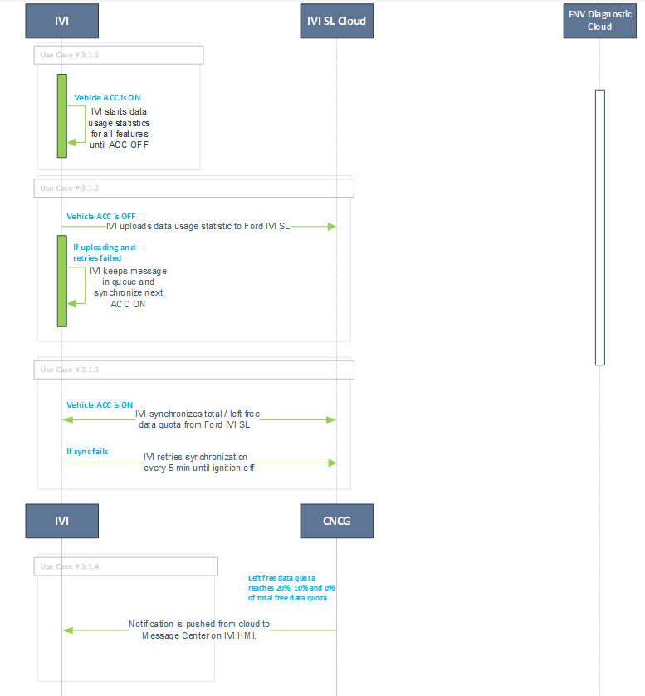



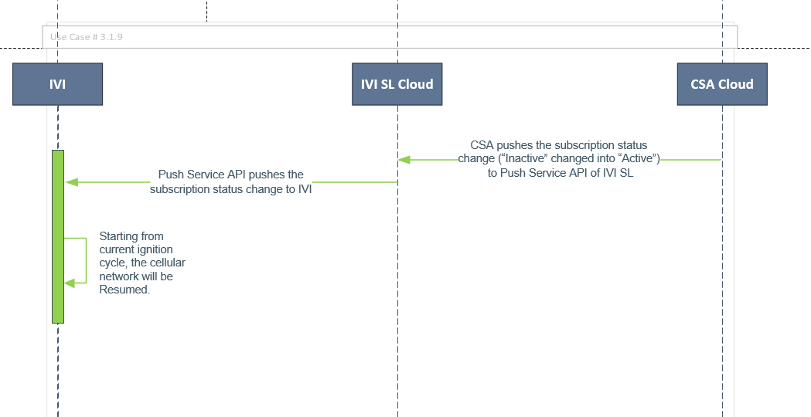

# Feature Requirements

## SYNC+ Requirements

### Data Usage Statistics & Upload

Carrier subscription features only cover applications which are configured on APN1 and Wi-Fi. IVI should be able to calculate cellular data usage by individual application, when data traffic is detected.

IVI should start data usage statistics since ignition on, IVI should end data usage statistics when ignition off, then upload data usage statistics to cloud (regardless of the returned subscription status).

### Retry Mechanism For Data Usage Upload

After ignition off, if data usage statistics uploading fails, IVI shall retry for 3 times. If all retries fail, IVI should keep the message in queue and retry further at next ignition on.

### 

### Free & Left Data Quota Sync-Up

A free experience package will be provided to new customer for trial. The duration is up to Marketing decision. When free experience package is present, the synchronized left free data quota will be shown in IVI MarketPlace for customer awareness, as soon as each ignition on.

At each ignition on, IVI should monitor if the data usage statistics has been successfully uploaded to Ford cloud since last ignition off. Once confirmed uploading is completed without message pending in queue, then IVI will start to synchronizes total free data quota and left data quota from Ford IVI service layer cloud.

Note: for CDX707, a 3-month free experience package will be provided to new customer for trial, which will be activated at vehicle authorization (the free trial start date will be determined by Ford subscription cloud). This package offers unlimited data for entertainment features, including SuiXinTing, iQiYi, DLNA, Muse, Cabin On-Live etc. During this free trial period, the total data usage and remained data usage synchronized from Ford subscription cloud will be both shown as unlimited.

### Retry Mechanism For Data Quota Sync-up

If IVI syncup of free & left data quota failed, IVI should retry synchronization every 5 min until ignition off.

In current ignition cycle, IVI should show customer the cached left data quota from last ignition cycle, until IVI successfully attains the latest free & left data quota from cloud.

### Subscription Status Sync-up

IVI should synchronize subscription environment and subscription status from cloud when ignition on.

The subscription status is retrieved by calling Subscription Status API on IVI service layer cloud. This status is passed through from Ford subscription cloud (CSA).

Subscription Status:

* Active: free experience package or customer paid subscription is activated.
* Inactive: free data quota has been depleted, however paid subscription isn’t activated yet; or a paid subscription is expired.

Definition of the parameter “SubscriptionUsage” in RetrieveSubscriptionUsageResponse API (cited from CSA API swagger):

type: object

properties:

appId:

type: string

description: "Appliaction id mapping between IVI and CSA\nQQ Musci = QQMUSIC\nHimalaya = HIMALAYA\nQButterfly Online FM = ONLINEFM\nIQIYI = IQIYI\nDLNA = DLNA\nMAP = MAP\nKTV = KTV"

example: IQIYI

minLength: 0

maxLength: 32

pattern: '[A-z0-9-]*'

status:

type: integer

format: int32

example: 0

description: active = 1, inactive = 0

minimum: 1

maximum: 1

exclusiveMinimum: false

exclusiveMaximum: false

totalUsage:

type: integer

format: int64

example: 10485760

description: carrier used usage, unit is KB. If the app is unlimited will be set as -1

minimum: 0

maximum: 1048576000000

exclusiveMinimum: false

exclusiveMaximum: false

remainUsage:

type: integer

format: int64

example: 10485760

description: carrier remian usage, unit is KB. If the app is unlimited will be set as -1

minimum: 0

maximum: 1048576000000

exclusiveMinimum: false

exclusiveMaximum: false

Subscription environment has Pre-Product and Product.

### Retry Mechanism For Subscription Status Sync-up

IVI should retry at least 3 time if synchronize failed. If IVI cannot synchronize subscription environment and status after ignition on, IVI should try to synchronize every 5 min.

In current ignition cycle, IVI should show customer the cached subscription status from last ignition cycle, until IVI successfully attains the latest subscription status.

### Feature Usage Analytics

During each ignition cycle, IVI should perform data usage statistics by feature, and at ignition off the statistics should be uploaded to FNV-diagnostic cloud for analytical purpose. Note this applies to all features onboard (ECG/TCU/IVI), not only those carrier subscription related features.

Feature usage analytical data should include below payload, as below table shows:

* Ignition on timeframe, ignition off timeframe (SYNC+ system time)
* Package Name
* Network interfaces (cellular, WiFi, etc.)
* Direction of data stream (sent, received)

|  |  |  |  |  |  |  |
| --- | --- | --- | --- | --- | --- | --- |
|  | **APN1** | | **TCU WiFi** | | **SYNC WiFi** | |
| **Application** | **Sent** | **Recv** | **Sent** | **Recv** | **Sent** | **Recv** |
| com.baidu.che.parking |  |  | 20 MB | 40 MB | 10 MB | 100 MB |
| com.baidu.iov.dueros.hotel | 50 MB | 200 MB |  |  | 100 MB | 300 MB |
| com.ford.ecg.CBZDATA | 13 MB | 400 MB |  |  |  |  |
| com.ford.sync.account |  |  |  |  | 5 MB | 30 MB |
| com.ford.ecg.FCI | 1 MB | 2 MB |  |  |  |  |
| …… |  |  |  |  |  |  |

### Retry Mechanism For Feature Usage Analytics Upload

If IVI uploads feature usage analytics data to cloud failed, IVI should retry maximum 3 times. If all retries failed, IVI should keep message in queue and try to synchronize next time ignition on.

### Error Logs

IVI should setup pre-define event for:

* Cannot communicate with Ford cloud backend (e.g. IVI SL, CSA, Ford Analytics Cloud etc.)
* IVI service / application crash

and upload logs to FNV-diagnostic cloud.

### Subscription control

The configuration of eligible network interface for individual application is still determined by WIR policy, however IVI should be able to control the cellular network access of the application according to subscription environment and status. When subscription status is changed to Inactive, applications can still be launched, but incapable of downloading or playing streaming media files with 5G celluar. Instead, customer can still leverage WiFi network access which is not impacted by subscription status.

If IVI cannot synchronize subscription status from cloud, IVI should show the cached subscription status.

### Exceptional rule

If the paid subscription package is expired during current ignition cycle, access to the cellular network should sustain until the ignition off, even if the customer hasn’t yet made a paid subscription to data.

This exception is to ensure good user experience and maintain driving safety, and applies to current ignition cycle only.

### IVI Swap

In case of IVI swap, IVI should retrieve the latest data usage statistics and subscription environment & status from Ford cloud, as soon as the new IVI boots up for the first time. The retry strategy is consistent with standard subscription synchronization.

If IVI synchronizes data usage statistics with cloud failed, IVI should retry maximum 3 times. If all retries failed, IVI should keep message in queue and try to synchronize next time ignition on.

### Retrieve Subscription Status after Push Service Notification

When customer made a payment for 5G data package and subscription status changed from Inactive to Active, Ford subscription cloud will push this status change notification to IVI (through Push Service API of IVI SL) in current ignition cycle. As soon as IVI receives this notification, it should call the subscription status API of IVI SL cloud instantly and retrieve the latest subscription status.

### Application scope scalability

Below is the current scope of applications planned for subscription control at SYNC+ 3.0 launch:

* Sui Xin Ting
* iQIYI
* DLNA
* Muse
* Cabin On-Live

Based on future business need, multiple subscription packages can be created, in which the applications could be added, removed or modified and whose type shall not be restricted to infotainment type only. For example, if basic service applications are configured to a free subscription period of 5 years since warranty start date, and subscription service shall be able to control the cellular network access of these basic service applications as well.

IVI SW should be able to extend the data usage statistics & subscription control capability to additional features, or remove that of existing features, based on the returned value from Ford cloud. For example, Ford cloud returns the subscription status (Active / Inactive) by individual package name, and IVI SW should turn on the data usage statistics and cellular network access for a feature if its subscription status is Active. In contrast, turn off if status is Inactive.

### Performance

Data usage statistics should balance data collection frequency and CPU load.

### Deviations

Data usage statistics is used for:

* Free data quota calculation (5G cellular only)
* Feature usage analytics (both cellular and WiFi)

It is not used for finance purpose.

TL should make KPI for deviation between data usage statistics and carrier billing, and validate in DVM.

### Local Cache Retention Period

IVI should retend the historical data usage statistics in local cache for 180 days, which shall be a configurable value.

### IVI notification

When calculated left free data quota reaches the pre-defined threshold (i.e. 20%, 10% and 0% of the total free data quota), Ford subscription cloud should push notification to Message Center on IVI.

During the driving cycle, it’s no longer needed for IVI to calculate the left free data quota locally.

Note: for CDX707, a 3-month free experience package will be provided to new customer for trial, so no need for this IVI notification push.

|  |  |  |  |  |  |  |  |  |
| --- | --- | --- | --- | --- | --- | --- | --- | --- |
| **Legacy Requirement** | |  | | | | | | |
| **Rationale** | |  | | | | | | |
| **Acceptance Criteria** | |  | | | | | | |
| **Notes** | |  | | | | | | |
| **Source** | |  | | | | **Owner** | Lu, Chao | |
| **Source Req.** | |  | | | | **V&V Method** |  | |
| **Type** | |  | | **Priority** |  | **Status** | Ready for Review | |
|  |  | | End of Requirement | | | | |

## Subscription Management Cloud Requirements

### Subscription status management

Subscription cloud should manage subscription status, to handle following cases:

* User purchase subscription
* Refund
* Free data quota deplete
* Subscription expires
* Free event from operation portal

### Free data quota

Subscription cloud should calculate left free data quota for vehicles, according to IVI uploaded data usage statistics.

### Inform subscription change

Subscription cloud should maintain the subscription status for each pre-defined subscription package on IVI.

Subscription cloud should inform IVI when subscription status changes.

Subscription cloud decides if IVI should inform user when subscription status changes.

### Subscription Status

Subscription Status API on IVI service layer cloud will pass through the status from Ford subscription cloud (CSA) to IVI.

Subscription Status:

* Active: free experience package or customer paid subscription is activated.
* Inactive: free data quota has been depleted, however paid subscription isn’t activated yet; or a paid subscription is expired.

### Application scope scalability

Below is the current scope of applications planned for subscription control at SYNC+ 3.0 launch:

* Sui Xin Ting
* iQIYI
* DLNA
* Muse
* Cabin On-Live

Based on future business need, multiple subscription packages can be created, in which the applications could be added, removed or modified and whose type shall not be restricted to infotainment type only.

Ford subscription cloud should return the appropriate value to IVI SW, to make the above subscription package scope change effective. For example, Ford cloud could returns the subscription status (Active / Inactive) by individual package name, and then IVI SW will turn on the data usage statistics and cellular network access for a feature if its subscription status is Active. In contrast, turn off if status is Inactive.

### Operation portal

Subscription cloud should provide portal for operation purpose.

Operation portal should provide:

* Change brand & model subscription environment
* Set free data quota and service period by subscription environment + brand + model
* Setup free event by subscription environment + brand + model
* Add or modify subscription status manually for specific VIN
* Look up the data usage by brand + model + VIN
* Create new subscription packages or modify / remove existing packages, in which the application could be added, removed or modified.

### Exclusivity of events

Ford subscription cloud should ensure that only one single event type exists for a specific vehicle at any time point. It should be avoided to have two event types present for one vehicle at the same time.

### Access

Operation portal should support Ford CDSID login.

Operation portal should be able to give different operation access to different CDSID.

### Setup subscription SKU

Operation portal should support carrier subscription SKU setup:

* Create new SKU for brand & model
* Update SKU
* Remove SKU
* Set new discount for specific SKU
* Show or hide specific SKU

### Order history

Operation portal should provide online mall order history for specific VIN.

Order information comes from online mall order definition.

### Cloud log

Subscription cloud should store last 30 days log. Log should contain:

* Communication between cloud and IVI
* Operation portal history

### Performance

Subscription cloud should response IVI in 5 seconds.

Subsciption cloud should support 300,000 vehicles, support 1,000 vehicles at the same period.

### Push Subscription Status Change

As soon as subscription status changed in Ford subscription cloud (CSA), Ford subscription cloud should leverage Push Service API of IVI SL to push a status change notification to IVI instantly, instead of waiting until next ignition cycle.

### Non Functional Requirement

Since IVI service layer cloud (Push Service API) is leveraged by Ford subscription cloud to push the subscription status change to IVI instantly, this API should meet below KPI:

|  |  |  |  |
| --- | --- | --- | --- |
| **Calendar Year** | 2023 | 2024 | 2025 |
| **Volume** | 100k | 300k | 500k |
| **Daily API Call (Lower Limit)** | 500 | 1500 | 2500 |
| **Daily API Call (Upper Limit)** | 6000 | 18000 | 30000 |

As IVI will call IVI SL cloud to synchronize the data usage and subscription status, both data usage API and subscription status API should meet below KPI:

|  |  |  |  |
| --- | --- | --- | --- |
| **Calendar Year** | 2023 | 2024 | 2025 |
| **Volume** | 100k | 300k | 500k |
| **TPS lower limit** | 1.39 | 4.17 | 6.94 |
| **TPS upper limit** | 6.94 | 20.83 | 34.72 |

### IVI Swap

In case of IVI swap, Ford cloud should be able to identify the vehicle by VIN and push the latest data usage statistics as well as subscription environment & status to this specific vehicle per request from vehicle.

### Push notification to App

Subscription cloud should push carrier subscription status change to mobile App.

## Ford Diagnostic & Analytics Cloud Requirements

### Error Logs

FNV-diagnostic cloud should provide relevant API for IVI to upload logs for pre-define events:

* Cannot communicate with Ford cloud backend (e.g. IVI SL, CSA, Ford Analytics Cloud etc.)
* IVI service / application crash

### Feature Usage Analytics

FNV-analytics cloud should provide relevant API for IVI to upload the data usage statistics by feature.

Feature usage analytical data should include below payload, as below table shows:

* Ignition on timeframe, ignition off timeframe (SYNC+ system time)
* Package Name
* Network interfaces (cellular, WiFi, etc.)
* Direction of data stream (sent, received)

|  |  |  |  |  |  |  |
| --- | --- | --- | --- | --- | --- | --- |
|  | **APN1** | | **TCU WiFi** | | **SYNC WiFi** | |
| **Application** | **Sent** | **Recv** | **Sent** | **Recv** | **Sent** | **Recv** |
| com.baidu.che.parking |  |  | 20 MB | 40 MB | 10 MB | 100 MB |
| com.baidu.iov.dueros.hotel | 50 MB | 200 MB |  |  | 100 MB | 300 MB |
| com.ford.ecg.CBZDATA | 13 MB | 400 MB |  |  |  |  |
| com.ford.sync.account |  |  |  |  | 5 MB | 30 MB |
| com.ford.ecg.FCI | 1 MB | 2 MB |  |  |  |  |
| …… |  |  |  |  |  |  |

## Mobile App Requirements

### Subscription status change

Mobile App should receive carrier subscription status change notification from Ford subscription cloud and show notification to customer.

# Non-Functional Requirements

## Data Usage and Collection

* Diagnostic service and analytic service in IVI should collect and aggregate the error message and data usage information, and subsequently upload to Ford Diagnostic & Analytics China cloud at regular reccurence (e.g. monthly).
* Ford should have the full ownership of all analytic data.

## Cyber Security and Privacy Control

PII and SPI should be well protected by supplier in data collection, processing and utilization, so as to comply with national legislation:

1. PII is:

* recorded electronically or by other manners;
* related to identifiable participants of transportation;
* not including information being anonymized already.

1. SPII: person information which might lead to discrimination to personnel, or serious damage to personal or property safety, once being disclosed or used illegally.
2. Obligation of Disclosure: it’s obligatory to disclose the types of PII being collected and processed, the scenarios of collection, channels to stop collections, etc.
3. Obligation of Consent Acquisition: it’s obligatory to acquire personal consent unless it’s compliant with legal requirements.
4. Anonymization Requirement: if PII is collected and distributed out of the vehicle for driving safety purpose but without acquiring personal consent, the PII should be anonymized.
5. Special Obligation:

* SPII: collection should be destined for limited purposes, collection status should be provided to customer proactively, and customer shall have easy access to stopping collection.
* Biometric data: collection should only occur for driving safety or other indispensable purposes.

# Feature Architecture

## Boundary Diagram



Figure 1: Functional Boundary Diagram

## Boundary Description





Figure 2: SYNC+ 3.0 Carrier Subscription & WFHS & Marketplace Delivery Boundary

# Appendix A: History

|  |  |  |  |
| --- | --- | --- | --- |
| **Author** | **Date (YYYY/MM/DD)** | **Status** | **Notes** |
| Shawn Lin,  Lu Chao | 2021/10/19 | DRAFT | Version 0.1 - Initial draft |
| Shawn Lin,  Lu Chao | 2021/11/17 | DRAFT | Version 0.3 – add system engineering comment and Boundary Description. |
| Shawn Lin | 2022/2/10 | DRAFT | Version 0.5 – add description of the data payload for feature usage analytics |
| Shawn Lin | 2022/2/28 | DRAFT | Version 0.6:  - update use case / sequence diagram for 3.1.4 / 3.1.7 and add use case / sequence diagram for 3.1.9;  - delete device ID and user ID from data payload in 4.1.1 and 4.2.2;  - update the feature usage analytic / statistics collection requirement in 4.1.1 (change “specific period” to “ignition cycle”);  - add NFR for subscription management cloud requirement and delete data usage notification requirement in 4.1.2;  - delete the message center notification requirement related to package service period in 4.1.2;  - add Retrieve Subscription Status after Push Service Notification requirement, update the subscription status / subscription control / synchronization sequence / IVI notification / application scope scalability requirements, delete subscription notification requirement in 4.1.3;  - add subscription status / application scope scalability requirement, update push subscription status change requirement and delete Online Mall URL decryption requirement in 4.2.1.  - delete the whole 4.4 Message Center Requirement. |
| Shawn Lin | 2022/4/6 | DRAFT | Version 0.7:  - Delete subscription control exception for free data quota depleted scenario in use case 3.1.8 and chapter 4.1.3, as it’s no longer valid.  - Chapter 4.1.2: add new requirement “Free Experience Package”  - Chapter 4.1.3: delete the requirement “synchronization sequence” and update the requirement “Subscription Status” |
| Shawn Lin | 2022/4/13 | DRAFT | Version 0.8:  - Delete “Network control scalability” in 4.1.3. |
| Shawn Lin | 2022/4/18 | DRAFT | Version 0.9:  - Reformatting per VSEM import requirement |
| Shawn Lin | 2022/5/5 | DRAFT | Version 1.0:  - Add CDX707 unique requirement i.e. 3-month free unlimited trial package. |